A list of bubble tea franchises

A bubble tea franchise

* Name
* Style

A list of bubble tea drinks

A bubble tea drink

* Name
* Syrup type
* Tea type
* Temperature
* Tea form
* Topping type
* Topping flavour

A list of locations

A location

A list of reviews

A review

* Username
* Date written
* Heading
* Body
* Rating

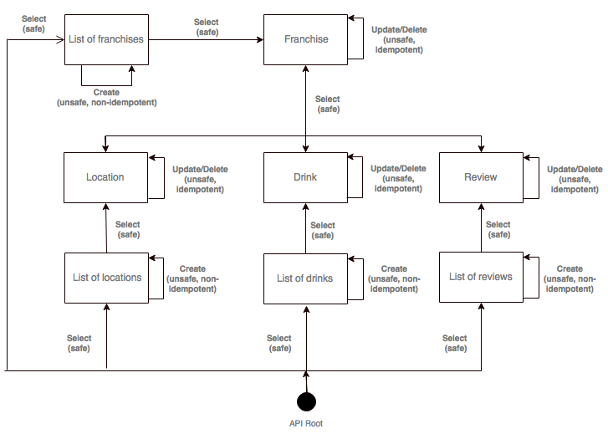

My problem domain surrounds the context of bubble tea — a drink that was first invented in Taiwan and comes in a huge variety of flavours and forms with interesting toppings. The API that I’ve built allows for the entry/retrieval of bubble tea franchises, their locations, drinks and reviews.

The models were built in a way so that it was structured around franchises. A franchise will have a name and the style of drinks. Style may be influenced by Western, Chinese or Japanese culture. For example, Bubbleology have introduced drinks that resemble sundaes. Each franchise will have a number of locations or branches. They will offer a range of drinks. Users may write reviews about the franchises.

The serializers file translates the data from the models into the default JSON format. HyperlinkedModelSerialzer was used as the way to generate the serialized objects so that hyperlinks are used as opposed to primary key relations (hence the use of a URL field). For the review serializer, the author of the review is automatically set based on who is logged in at that time. The franchise serializer is able to return all location, drinks and reviews associated with a single franchise.

The ModelViewSet class is used to display the data. It looks into each model and returns associated objects accordingly. This class enables both list and detail views of objects automatically.

**ADDITIONAL FEATURES**

The URL uses an API naming convention by following versioning, set in URLs.py — “api/v1/”.

Data is not only returned in JSON and HTML but also XML and YAML. This can be achieved by adding the file type suffix to the end of a URL. POST requests can also be made. Through the browseable API, a HTML form is used to make POST/PUT. Objects can also be deleted. Permissions were implemented so that only superusers can create/update franchises, locations and drinks. Only logged in users can make reviews. All other users (anonymous) have read-only access to the API. API documentation can be accessed through <http://myapp-anand.apps.devcloud.eecs.qmul.ac.uk/docs> . Objects can be filtered using the URL:

|  |  |
| --- | --- |
| Model | Query Parameters |
| Franchise | Name, Style |
| Location | Franchise_location |
| Drink | Temperature, Tea_Type, Tea_Form |
| Review | Franchise_review |

**URL**

<http://myapp-anand.apps.devcloud.eecs.qmul.ac.uk/api/v1/>